Fall Family Fun
If you've never been to a corn maze, you don't know how much fun they are! Open for our 7th season, we are pleased to offer you 6+ acres of fun for the entire family to enjoy! Over 2 miles of Corn Maze is open for daytime fun or nighttime flashlight fun. Hours of operation vary by day & are dependant on weather conditions. To check the times for the Corn Maze, please give us a call at 814-734-2833 or 866-203-5268 for the most up-to-date information.

I hope to see you at the Wooden Nickel Buffalo Farm’s Corn Maze!

Col. Corn Cob

Game Maze Admission:
- 4 & under FREE
- Ages 5-54 $7
- Seniors age 55+ $5
Whether a Tourist or Local to NW Pennsylvania:
If you are in the Edinboro/Erie Area, you will want to visit the Wooden Nickel Buffalo Farm, Gift Shop, and Eatery. View a working Buffalo Farm where over 50 American Bison roam on 100-acres of beautiful Northwestern PA farm land. Visit for the day or come for the week to take advantage of all of the amenities that our area has to offer. www.WoodenNickelBuffalo.com for more information.
Maze & Gift Shop Hours

Aug 26-Oct 1 Sun-Thurs 11a-6p
Friday & Saturday until *9p
Labor Day 11a-*9p
Oct 2-Nov 5 Daily 11a-*9:30p
*Last entry for Maze. We stay open an hour after last group has entered. Eatery (Restaurant) Closes at 6pm each day

Nov. 6-Dec. 31 Gift Shop Open
Sat. & Sun. 11a-5p or by appt or chance

2017 Jan, Feb, & March: By Appointment or Chance Call 814-734-2833 or 866-203-5268



Open Daily Aug 26-Nov 5, 2016
Open extended hours in October.
Call or go online for current hours.

Corn Maze-Live Bison-Petting Zoo

Eatery-Gift Shop

5970 Koman Rd-Edinboro PA

814-734-2833 or 866-203-5268
Email: buffalo@velocity.net
www.WoodenNickelBuffalo.com


If you haven't been to a corn maze, you don't know what you're missing...and you may not know what to expect! The Wooden Nickel is a working farm. If it rains, there will be mud. Open-toed shoes or shoes that cannot be easily washed are not recommended.

There are 2 types of Corn Maze fun at the Wooden Nickel Buffalo Farm

1. Daytime Maze-This is perfect for families and small children, and cold days! The corn is a variety that normally grows about 6-8 feet tall and creates a thick maze. “Buffalo Dan” uses a zero-turn mower equipped with GPS to cut the pattern of paths into the field. The pattern is only visible from the air, but on the ground it is a great maze. It should take anywhere from 30 minutes to 2 hours to complete the game and find all 16 mailbox stations.

2. Nighttime Maze-Same as a daytime maze...but at night with flashlights! A slightly scary but fun experience. Very popular with teenagers! If you forget your flashlight, no worries, we rent them for $1 plus refundable deposit.

****Don’t forget to bring****
**** a flashlight for ****
**** “Night Stalking” ****

***Open 8/26-11/5/2016***
Corn Maze Hours:
Gift Shop stays open Maze Hours.
Aug 26-Oct 1 Sun-Thurs 11a-*6p
Friday & Saturday until *9p
Labor Day 11a-*9p
Oct 2-Nov 5 Open Daily
11am-*9:30p
*Last entry for Maze. We stay open an hour after last group has entered
Advance reservation discounted group rates for 10 or more.

Eatery (Restaurant) serving until 6p during Maze Season

Theme: Family Tree
Below is the 2016 Maze Design:
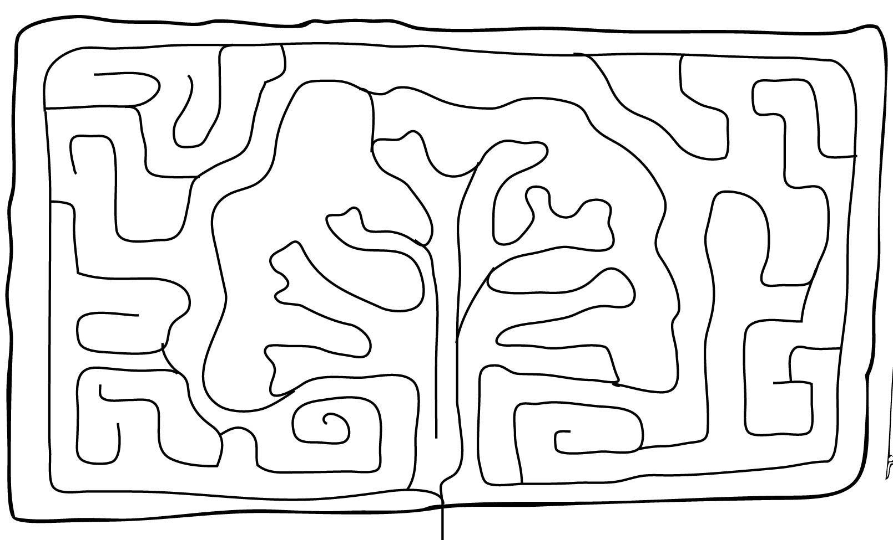

Cost:
4 & under free
Ages 5-54 $7.00
Seniors 55+ $5.00

Flashlight rental $1 plus deposit

Navigate through 6-acres of corn-fusing trails & stop at each of the 16 stations throughout the Maze.

The fun doesn’t stop once the sun goes down! Try to navigate the Maze armed with a flashlight while avoiding other “Corn Stalkers”.
Visit the WoodenNickelBuffalo.com Corn M
aze page for more info.

