Wooden Nickel Corn Maze Game Sheet 2018
Army
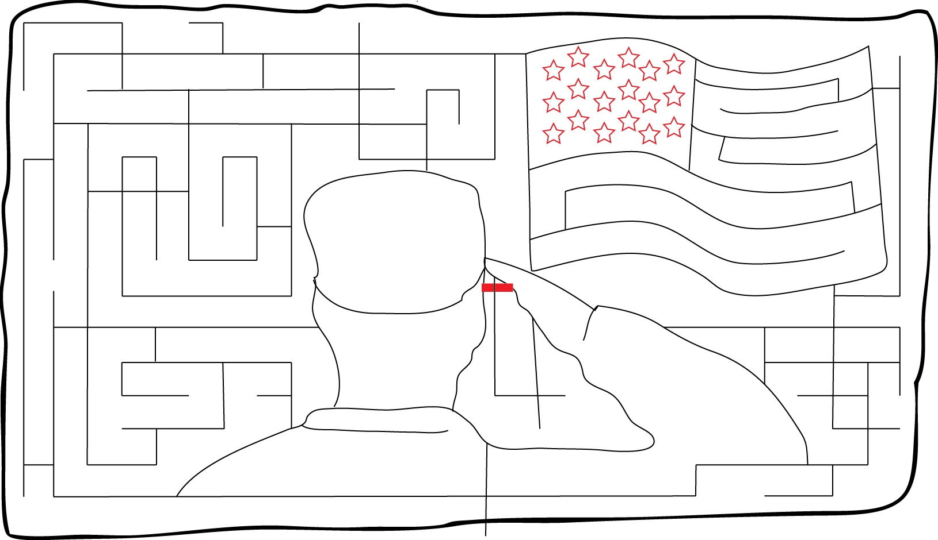
Seal Team
Helicopter
Air Force
Base
Navy
Marine
Barracks

Drone
Tank

Submarine

Torpedo
Infantry
Aircraft Carrier
Special Forces
Maze Entrance & Exit
Salute to our Military
Coast Guard
Wooden Nickel Buffalo Farm, 5970 Koman Rd, Edinboro PA 16412
Phone 814-734-2833 or 814-434-6212, BuffaloDan1963@live.com, www.WoodenNickelBuffalo.com

