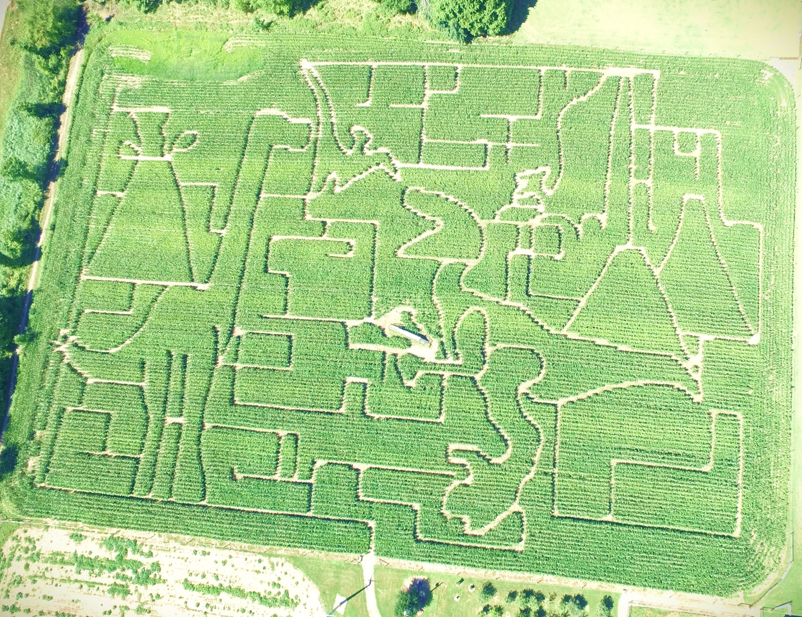
Wooden Nickel Buffalo Farm
5970 Koman Rd, Edinboro PA

2022 Corn Maze-Dinosaurs Rule!

